BASINGSTOKE CHESS CLUB NEWSLETTER (MAY 2023)
STEVEN JONES COACHING
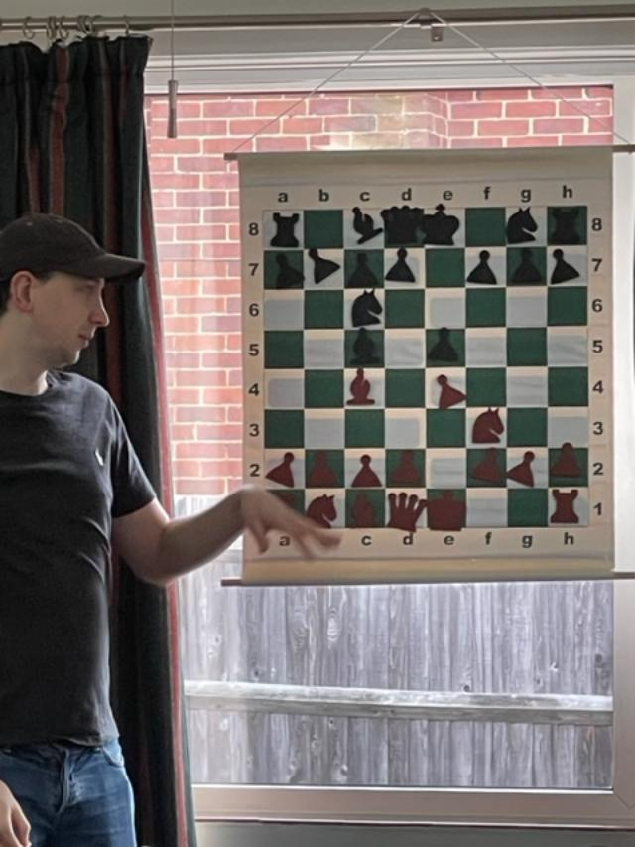
JUNIOR SESSION
The next coaching Session from Steven Jones will take place on Wednesday 17th May 2023 at the club. The start time is 5.30pm and we request that all effort is made to arrive on time. This session is for the benefit of the Junior members and the Chess Club are sponsoring the event. Steven is one of the strongest players in the country and in most years competes in the British Championship. In addition he enters many of Chess Congress’s around the country and in 2022 secured 4 joint first place prizes. Recently he entered the very strong Guildford Congress and came second in a very strong field. Locally he has been Basingstoke Individual Chess Champion for the last three occasions it has been held. The coaching is certain to benefit the club juniors. With the younger and less experienced players a separate coaching session may be run if required.
BASINGSTOKE JUNIOR INDIVIDUAL CHAMPIONSHIP.
The above competition has been scheduled for Sunday 4th June 2023. The start time is 10.30am and is likely to finish around 1.00pm. Entrants must be under 15.
All entrants will receive a trophy as in previous years with the winner being presented with the Silver Bishop Trophy. This will be the final junior event of the season which restarts in September.
DELANCEY MEGAFINALS

2023 Hampshire Megafinal
£30.00
Date: Sunday 25th June
Venue: Winchester College (New Hall), College Street, Winchester, Hampshire, SO23 9NF
Eligibility: Open to all juniors born after 31/08/2004
Schedule: Arrival from 9.30 for a 10.00 start. Approximate finish time 17.00
Organiser Details: Maha Chandar, kidschess@hotmail.com
Closing date for last entries: 22nd June
Time control: 20 minutes + 10 seconds
ECF rated: Yes
Other information:
***Please note the organiser has the right to make changes to the above on the day if required
STEVEN JONES ADULT SESSIONS
Following on from the English Opening in March the April session was on the Evans Gambit. Excellent research and analyses was provided in what is one of the more aggressive openings in chess.

LEAGUE NEWS
SOUTHAMPTON LEAGUE
April 2023 saw six scheduled matches which resulted in 2 wins and 4 losses.
A Team: (Division 2) No matches for the A team during the month. However results elsewhere mean that the team need a draw in the forthcoming last match against Hamble A to win the Division.
B Team: (Division 3) There were two matches scheduled but sadly only one took place. This was due to my car breaking down on the day of the fixture at Southampton A. As Southampton had already won the Division we agreed to concede the match. The second match resulted in a 3-2 win which confirmed second place for the team. The points came from wins by Megan Birch and Liam Durangparang plus draws by Ralph Morley and Andrew Birch.
C Team: (Division 4) The final C team match saw Chandlers Ford B clinch the league with a 3-1 win. However the games were well contested with two draws by Andrew Birch and David Long making up the stoke point.
D Team: (Division 5) The D team had mixed fortunes. They recorded an excellent win at Southampton D with wins by Uger Mentes and Nick Judson plus a draw from David Long bringing up a 2 ½ - 1 ½ win. The team played the last match at Salisbury D and lost 3-1. An Ashok Vookla win scored the point.
Robertson Plate: (combined C +D teams) The semi final at Southampton C ended in a 3-1 defeat with Shwetal Bhatt getting the Basingstoke point.
http://www.sotonchessleague.org.uk/
DISCOVERY CENTRE:
There was a good attendance of 24 for the April Family morning. The next scheduled meeting will be on Saturday 20th May 2023 . The session is from 10.30am until noon and it is free.
BASINGSTOKE CHESS LEAGUE
The Basingstoke Chess League is an informal competition for members and friends of the club. The teams are selected from the players area of residence or a grouping. In the past the 4 teams have been. Basing, Kempshott, Central and the Juniors. The games are 30 minutes for all moves and two rounds played. In previous years the teams have comprised of 4 players. With the increase in membership the following changes will be introduced.
- There will be 6 teams. The Junior players will be incorporated into the respective area or grouping team. The Junior team will be disbanded.
- The 6 teams will be Tadley. Popley, Kempshott. Basing. Central and Shwetal’s pawnpushers from Oakridge.
- There are no individual trophies awarded and all games are ungraded. The winning team gets the Alekihine Trophy for a year.
- The matches comprise of two rounds of games. Each game is 30 minutes for all moves. Players may be substituted for the second round of games to ensure all who want to play can.
- Effort will be made to avoid mis-matching of opponents.
After 2 rounds the points are : Central 12 ½ , Tadley 11, Oakridge 11, Kempshott 9, Popley 9, Basing 7 ½
- Fixtures:
Wednesday 3rd May Tadley v Central, Kempshott v Oakridge
Wednesday 10th May Basing v Popley, Tadley v Kempshott
Wednesday 17th May Central v Oakridge, Basing v Tadley
Wednesday 24th May Popley v Central, Kempshott v Basing.
Wednesday 31st May Oakridge v Popley
Results annexed to the Newsletter.

CLUB WEBSITE: Keep up to date with Basingstoke Chess Club news from the club’s website. https://www.basingstokechessclub.co.uk/

Best Regards, DAVID

